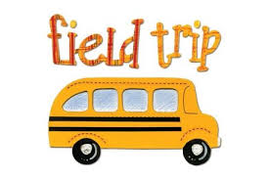  Harrisburg/Indian Echo Caverns  Thursday, March 5, 2020  - Please arrive to Glen Acres by 7:45. We will leave at 8:00a.m.  - Bring a disposable lunch – NO GLASS  - Bring a bag to carry your lunch  - Bring a jacket or sweatshirt for Cavern  - NO ELECTRONICS  - No money should be brought on the field trip.  - Have arrangements to be picked up at Glen Acres at 4:00pm | Harrisburg/Indian Echo Caverns  Thursday, March 5, 2020  - Please arrive to Glen Acres by 7:45. We will leave at 8:00a.m.  - Bring a disposable lunch – NO GLASS  - Bring a bag to carry your lunch  - Bring a jacket or sweatshirt for Cavern  - NO ELECTRONICS  - No money should be brought on the field trip.  - Have arrangements to be picked up at Glen Acres at 4:00pm

